DOCUMENT TECNIC SOBRE ELS DIFERENTS SENSORS DEL NOSTRE PROJECTE

Sensor de proximitat Ultrasons HC-SR04:

|  |  |
| --- | --- |
| **Power Supply** | 5V DC |
| **Working Current** | 15 mA |
| **Working Frequency** | 40 kHz |
| **Maximum Range** | 4 meters |
| **Minimum Range** | 2 cm |
| **Measuring Angle** | 15º |
| **Resolution** | 0.3 cm |
| **Trigger Input Signal** | 10uS TTL pulse |
| **Echo Output Signal** | TTL pulse proportional to the distance range |
| **Dimensions** | 45mm x 20mm x 15mm |

HC-SR04 Ultrasonic Sensor Pinout

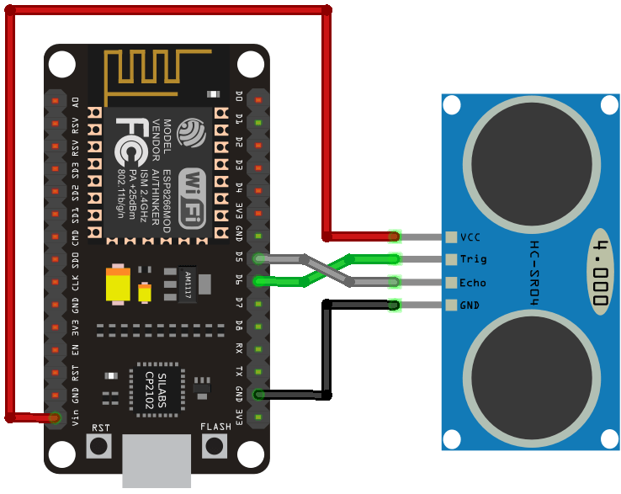

|  |  |
| --- | --- |
| VCC | Powers the sensor (5V) |
| Trig | Trigger Input Pin |
| Echo | Echo Output Pin |
| GND | Common GND |